Psychophysiological comfort during active urban mobility: Environment and activity modulated physiological and perceived responses across diverse urban contexts

Abstract
In this paper we assess route contrasts (H1, H3), unadjusted correlations with votes (H2), physical sensor regressions (Analysis), and the sound effect during thermal discomfort (H4).

Urban active travel exposes people simultaneously to thermal, acoustic, visual and physical demands, yet these exposures are rarely studied together under naturalistic conditions. This repeated-measures field study examined psychophysiological comfort across cycling and walking phases in impervious urban and green environments in Brussels. Eleven participants completed route phases while wearable physiological, mobile eye-tracking and environmental data were synchronized to 10-second epochs. Linear mixed models tested environment and mode, literature-based tests examined whether noise amplifies thermal stress, and an additive mixed model estimated all exposures together, with repeated measures accounted for and Benjamini-Hochberg correction applied within hypothesis families. Green phases were associated with lower skin temperature and larger pupil diameter (pupil is illumination-sensitive). Walking versus cycling differed mainly in ocular kinematics (pupil, blink, fixation, gaze velocity, dispersion, and gaze position) in the locked phase-mean export. No heat-by-noise interaction survived false-discovery-rate correction in any literature-based H4 test on calibrated ucm_SND_dBA. Five of 110 fitted questionnaire–physiology pairs reached q_FDR < 0.05 in H2 (H2_Concordance.csv; prespecified grid 18×26 = 468; BH within fitted pairs only); broad psychophysiological concordance was not supported. These findings indicate distinct physiological and visual-attention signatures across mobility contexts, while the small sample, model diagnostics and observational field exposures limit causal and population-level claims.
Keywords: active mobility; green infrastructure; thermal comfort; wearable sensing; mobile eye tracking; linear mixed models

1 Introduction

1.1 Background and research gap
Active mobility is increasingly promoted as part of low-carbon and healthy urban transport, but route choice also determines exposure to heat, noise, traffic and visual complexity. Outdoor comfort is adaptive and context-dependent rather than a direct function of meteorological conditions alone (Nikolopoulou et al., 2001).
Naturalistic mobility studies must consider environmental exposure and physical travel demands together. Physiological measures can complement self-report, but they are not direct or unique readouts of comfort: electrodermal activity reflects sympathetic arousal, skin temperature is influenced by thermoregulation and movement, and wrist-derived heart-rate variability requires careful measurement and interpretation (Boucsein et al., 2012; Quigley et al., 2024; Stuyck et al., 2022).
Existing field studies commonly examine walking or cycling separately. Mobile eye tracking is feasible outdoors but remains sensitive to illumination, motion, calibration and scene complexity (Evans et al., 2012; Mahanama et al., 2021). Cycling studies further show that gaze allocation changes with task and road context (Rupi & Krizek, 2019).
Wearable physiological sensing can support thermal-comfort research, but much of the evidence comes from controlled or indoor exposures (Mansi et al., 2022). Cross-domain effects are plausible: daylight can alter thermal perception even under controlled thermal conditions (Chinazzo et al., 2019), illustrating why field responses should not be assigned to a single exposure in isolation.
A central evidence gap is the within-person comparison of walking and cycling across contrasting urban and green route phases while environmental, physiological, eye-tracking and perceived responses are measured together.
This study addresses that gap using repeated phase blocks in one field protocol. The design supports within-participant association estimates across the observed routes; it does not establish that greenery, mode or individual stressors independently caused the responses.
The contribution is the integrated comparison of environment and mobility mode, separation of primary and sensitivity analyses, and joint examination of thermal and acoustic exposure in a naturalistic active-mobility setting.
The study asks whether response profiles differ between green and impervious urban phases, between walking and cycling, whether physiological and perceived responses covary, and whether the thermal association changes with concurrent noise.
The results can inform hypotheses and measurement priorities for larger urban-mobility studies and, cautiously, route designs intended to reduce combined environmental burden.

1.2 Hypotheses
We hypothesise that:
1. H1 — Green versus impervious comfort. Participants show better physiological and perceived comfort in green than in impervious areas.
2. H2 — Physiological and perceived concordance. Physiological and perceived responses are concordant.
3. H3 — Cycling versus walking. Psychophysiological comfort is more compromised during cycling than during walking.
4. H4 — Noise and thermal discomfort. Noise and traffic-related sound amplify thermal discomfort.
5. Analysis — Combined exposure. Additive models describe adjusted associations when thermal, acoustic, radiative, pollution, and route-context terms co-occur. This block is not a hypothesis test.

2 Methods
Urban-comfort and mobile-exposure papers typically combine design, measurements and analysis in one flow rather than separate “instruments” and “procedure” sections. Measurements are described where they support the analysis grain (here: matched route phases and 10-second epochs). The subsections below follow that convention.

2.1 Study design
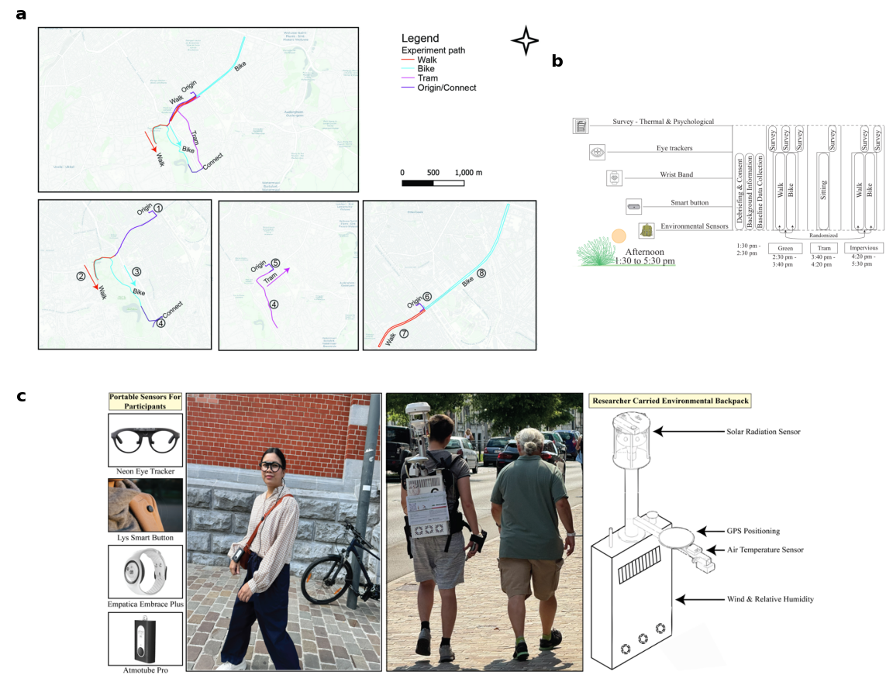
Figure 1. Study design: four core route phases (walking and cycling in impervious and green corridors) plus a descriptive tram segment.
A repeated-measures field campaign was conducted in Brussels, Belgium, from 3 July to 27 August 2025. Each participant completed four core outdoor mobility phases—cycling and walking in impervious urban corridors and in green-park corridors—plus a seated tram phase (descriptive only). Phase labels were BikeU, WalkU, WalkG, BikeG and Tram; tram was excluded from the primary 2 × 2 environment-by-mode contrasts.
Randomization of route order was planned. Participants completed questionnaires before and after each block; wearables and the trailing-researcher uCM backpack were checked at breaks. All streams were time-aligned to UTC. The design targets within-person comparisons of environment and mode under naturalistic active mobility; route location, workload, illumination and co-exposures co-vary with phase, so inferential models estimate associations, not single-stressor causation.

2.1.1 Participants
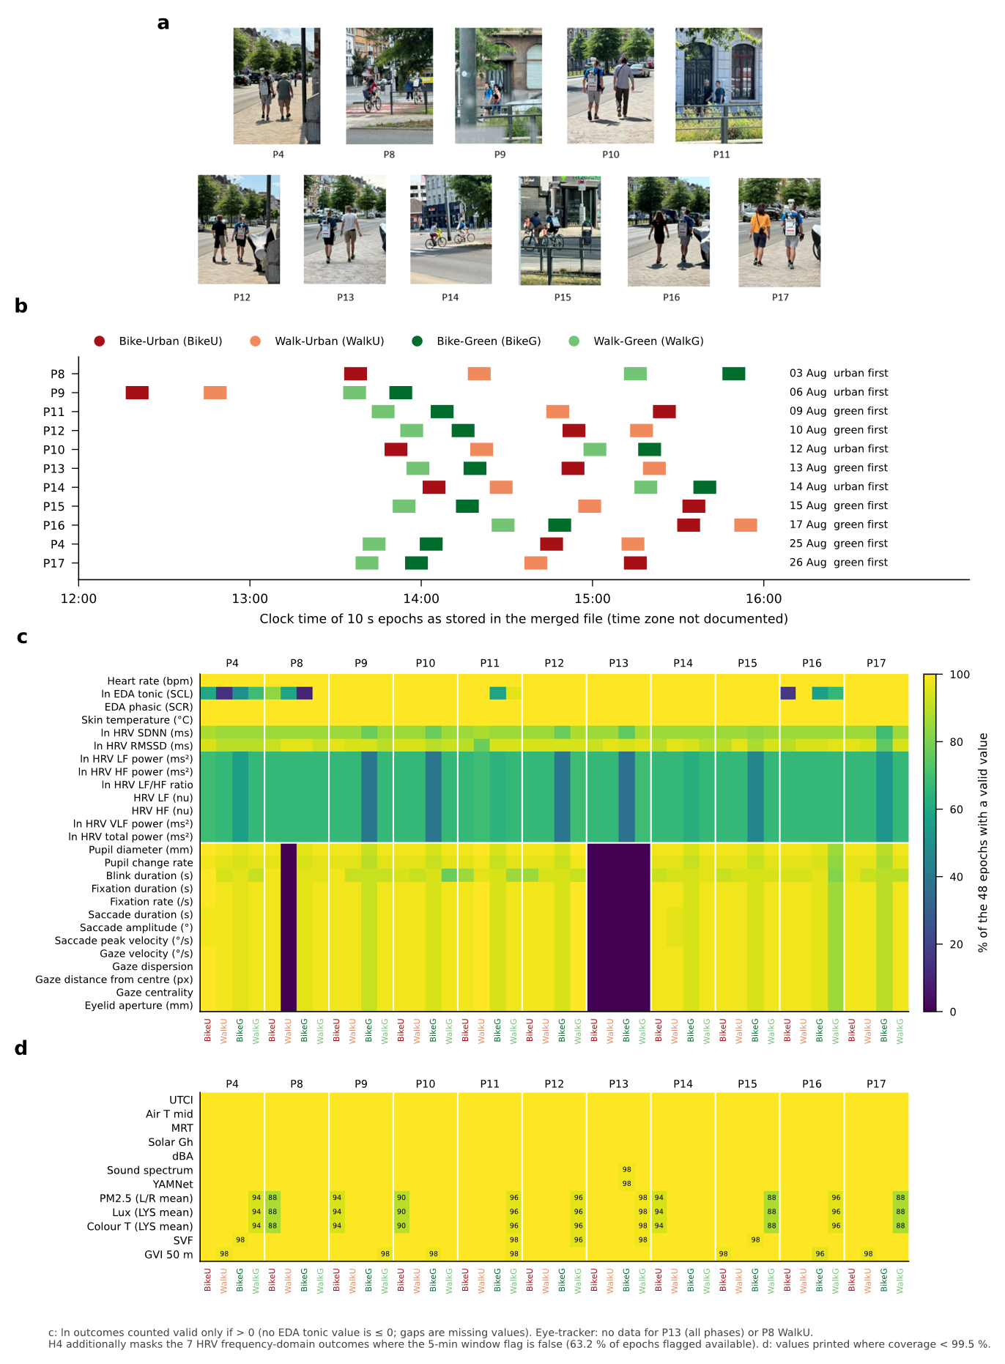
Figure 8. Participant coverage across the four core phases.
Eighteen volunteers were tested (30 planned under ethics). Eleven with complete multi-sensor coverage on the four core phases were analysed (P4, P8–P17). Inclusion criteria were age 18–60 years, Brussels residence, ability to walk and cycle the study routes, and vision compatible with mobile eye tracking. Ethics application signed 28 May 2025 (approval reference from approved PDF). With n = 11 and four repeated phase cells, post hoc sensitivity (GPower, α = 0.05, power = 0.80, r = 0.50) suggested minimum detectable f ≈ 0.52. Using partial η² = f² / (1 + f²), that f is about 0.21, not 0.11.
The analysed sample comprises eleven participants (three women, eight men) aged 24–58 years (mean 35.2 years, SD 9.5), within the 18–60 year inclusion range. Self-reported height and weight yield BMI 20.5–33.0 kg·m⁻² (mean 23.8 kg·m⁻², SD 3.8): eight meet WHO normal weight (18.5–24.9 kg·m⁻²), two are overweight, and one has obesity. Project case-study labels classify eight as Fit and three as Not Fit and six as Active and five as Inactive (BMI- and daily-walking–based rules applied to the same eleven IDs). Clothing-questionnaire skin tone (Very fair, Fair, Medium, Olive, Brown) is mapped to Fitzpatrick types I–V by ascending shade (I, n = 1; II, n = 6; III, n = 2; IV, n = 1; V, n = 1; no type VI), covering the range where wrist photoplethysmography and optical heart rate on Empatica wearables may perform unevenly across pigmentation (Bent et al., 2020). Seven participants normally wear glasses; four report no vision correction.
Archived mixed models that enter those Fit/Not Fit and Active/Inactive labels as person-level factors are sensitivity analyses only; none of their coefficients survive Benjamini–Hochberg FDR control in the primary hypothesis families reported here.

2.2 Data preparation
Micrometeorology and context (uCM, 10 s): air temperature, humidity, mean radiant temperature, global horizontal irradiance, wind, A-weighted sound (dBA), GPS, UTCI and PET. Air quality and light: PM (Atmotube means), lux and colour temperature (LYS means). Scene openness (CamUp / Mapillary pipelines): Holmer annular sky view factor (SVF) for inferential models; tree view factor (TVF) and building view factor (BVF) computed alongside SVF but not co-entered with SVF or GVI in the combined-exposure model (Gong et al., 2018). Greenery: eye-level GVI (gvi_50m). Physiology (Empatica): EDA tonic/phasic, heart rate, HRV, wrist temperature. Vision (eye tracker): pupil, blink, fixation and gaze kinematics; proprietary eyetracker_stress_composite retained in the merge for exploration only. Perception: end-of-phase comfort and environmental-comfort items, STAI-6 item scores, PRS-11 subscale means (18 questionnaire columns in H2/H1–H3 exports).
Streams were synchronized, path-matched and quality-checked, aggregated to 10-second epochs, then—for the phase-mean analyses (H1–H3 and the phase-mean combined-exposure model)—collapsed to participant × phase means on matched eight-minute segments (44 cells). Clearness index (k_t) was computed for solar QC; measured irradiance (ucm_SUN_Gh) entered models, not derived k_t. Transformations followed the locked normalization CSV.
Sound exposure (two streams): Primary loudness is the uCM calibrated A-weighted level ucm_SND_dBA (10 s medians on the backpack stream). Supplementary descriptors from phase WAVs include YAMNet source-type proportions/scores, Welch band energy shares, octave summaries, and spectral centroids (Sound spectrum in field experiment.md). These are not interchangeable with calibrated dBA; low-frequency band fractions can correlate with classifier “wind” labels and with apparent wind on the body during cycling—interpret as type/frequency structure, not as a second loudness standard.
Wind and microphones: Outdoor noise guidance (FHWA field measurement practice; ISO 1996-2:2017 measurement context; mobile mapping: Zuo et al., 2016) treats high wind as a measurement-condition issue even with windscreens. A 5 m/s apparent-wind exclusion on ucm_WIND_AWS was implemented as an optional sensitivity for supplementary sound models only (not a decibel correction). Literature (Cooper & Evans, 2015) cautions that a 5 m/s cutoff alone does not guarantee absence of wind-on-microphone artefacts. Windscreen type and microphone placement on the uCM should be stated from field notes in the final manuscript.

2.3 Statistical analysis
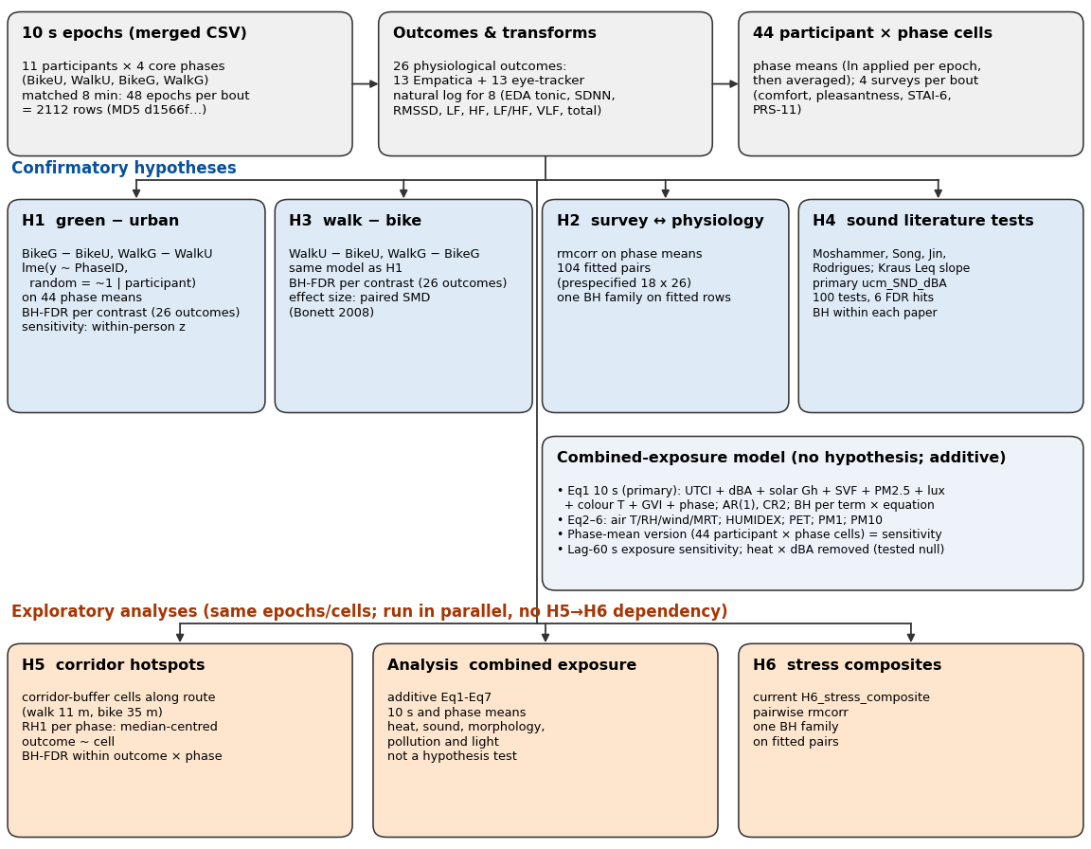
Figure 2. Analysis flow from synchronized epochs to phase-mean hypothesis tests and the additive combined-exposure models.
Primary inference used REML linear mixed models (Pinheiro & Bates, 2000) on participant × phase means to target within-person contrasts and limit pseudo-replication from epoch-level counts (Cnaan et al., 1997; Enders & Tofighi, 2007), with planned contrasts from estimated marginal means (Lenth, 2023) and questionnaire–physiology coupling via repeated-measures correlation (Bakdash & Marusich, 2017). Benjamini–Hochberg FDR (α = 0.05; Benjamini & Hochberg, 1995) was applied within prespecified hypothesis families. Unbalanced repeated-measures field designs follow ambulatory precedent (Rodrigues et al., 2026; Korkmaz et al., 2025).
- H1 — Green versus impervious comfort:
- Citation: Pinheiro & Bates (2000); Cnaan et al. (1997); Enders & Tofighi (2007); Lenth (2023); Benjamini & Hochberg (1995); Rodrigues et al. (2026); Korkmaz et al. (2025).
- Model: Phase-mean REML LMM: Y ~ PhaseID + (1 | ParticipantID); emmeans contrasts; BH FDR within each contrast over 26 physiological outcomes (H1.1 and H1.2 are separate families, n = 26 each—not one pooled family of 52). Questionnaire contrasts use separate BH families (18 items × contrast). Sensitivity: within-person z-scored (WPZ) repeats the same family structure. Optional 10 s / 60 s AR(1) (H1_H3_timeseries.R) does not include grid_f. In H1_H3_Temporal_AR1_10s.csv, 63 of 546 coefficient rows are flagged rho > 0.95, and the heart-rate phase terms have standard errors in the millions (the same three terms repeated). Do not quote those rows. Phase-mean H1 does not use this file.
- Description & sub-parts: H1.1 BikeG − BikeU (green vs impervious, cycling). H1.2 WalkG − WalkU (green vs impervious, walking). Primary grain: participant × phase means on matched 8 min segments (44 cells); 26 physiological and ocular outcomes. Script: H1_H3_phaseavg.R; exports H1_H3_Contrasts.csv, H1_H3_Temporal_AR1.csv.
- H2 — Physiological and perceived concordance:
- Citation: Bakdash & Marusich (2017); Benjamini & Hochberg (1995).
- Model: rmcorr; prespecified grid 18 × 26 = 468 pairs; one BH family over the fitted questionnaire–physiology pairs (H2_Concordance.csv). Twenty-one pairs have q < 0.05.
- Description & sub-parts: Phase-mean concordance between comfort, environmental comfort, STAI-6 items, PRS-11 subscales and the same 26 outcomes used in H1. Fitted jointly with H1 in H1_H3_phaseavg.R; export H2_Concordance.csv.
- H3 — Cycling versus walking:
- Citation: Pinheiro & Bates (2000); Cnaan et al. (1997); Enders & Tofighi (2007); Lenth (2023); Benjamini & Hochberg (1995).
- Model: Same phase-mean LMM shell as H1; emmeans; BH FDR within each mode contrast over 26 physiological outcomes (H3.1 and H3.2 separate families, n = 26 each); questionnaire and WPZ families as for H1.
- Description & sub-parts: H3.1 WalkU − BikeU (mode contrast, impervious urban). H3.2 WalkG − BikeG (mode contrast, green). Descriptive (not confirmatory): difference-of-differences (BikeG − BikeU) − (WalkG − WalkU). Exports: H1_H3_Contrasts.csv (Hypothesis = H3); sensitivities as H1.
- H4 — Noise and thermal discomfort:
- Citation: Moshammer et al. (2019); Song et al. (2013, 2014); Jin, Jin and Kang (2020); Rodrigues et al. (2026); Kraus et al. (2013); Benjamini & Hochberg (1995); Mansi et al. (2022); Chinazzo et al. (2019).
- Model: Literature-derived tests in H4_sound_literature_test.R (not a preregistered protocol). BH FDR within each paper’s own test × outcome family. Screening rule in METHODS_NOTES.md: four papers included; Kraus excluded from that rule because the source model has no thermal term, while the Leq slope is still fitted and reported separately.
- Description & sub-parts: Moshammer, Song (park-versus-street HRV sensitivity; no dBA term in the source), Jin (the heat × sound ANOVA), Rodrigues (noise-block mixed model). Kraus slope is extra. Heat × noise claims use Jin on ucm_SND_dBA. Jin’s ANOVA has no participant block, matching the source paper’s independent-respondent analysis; that is written on the test label.
- Not confirmatory H4: Superseded Eq1–7 sensitivity pipelines (Analysis_combined_timeseries.R, Analysis_combined_phaseavg.R; archive names H4_timeseries.R, H4_phaseavg.R) differ by grain in predictors and VIF—exploratory Analysis only (§2.3 item 7), not literature-test H4.
- Analysis — Combined exposure:
- Citation: Mansi et al. (2022); Chinazzo et al. (2019); Rodrigues et al. (2026); Hamra & Buckley (2018); Marquardt (1970); James et al. (2013); Fox & Monette (1992); Pinheiro & Bates (2000); Benjamini & Hochberg (1995).
- Model: Additive REML LMMs (main effects only); not a hypothesis test. Collinearity: VIF = 1/(1 − R²); Fox–Monette block VIF for PhaseSum route block. Screen max VIF < 10 on heart-rate complete cases per fitted grain (Analysis_combined_gvif_summary_both_grains.csv); drop predictors only where that grain fails screening.
- Description & sub-parts: Analysis — timeseries (10 s): Analysis_combined_timeseries.R; one additive LMM per outcome × Eq1–7; BH *q* per fixed term within equation × 26 outcomes (separate families per contrast × outcome set in code.); includes ucm_SUN_Gh and gvi_50m where listed; Eq3 primary at this grain (phase Eq3 excluded at max VIF 22.48). Current 10 s equations do not include grid_f. Do not describe them as rank-deficient for that reason. Quote coefficient rows only when the standard error and AR(1) flag are usable. Analysis — phaseavg (phase means): Analysis_combined_phaseavg.R; same Eq1–7 structure on participant × phase means (182 / 182 fitted in audit; many low effective-df coefficient flags—exploratory, not confirmatory); omits SUN and GVI on all equations; Eq2 phase spec: ucm_AIR_T_mid, ucm_AIR_RH, ucm_WIND_AWS + SVF + PM2.5/lux/kelvin + PhaseSum (no SND; max VIF 9.29 vs 10 s Eq2 1.61). Shared non-thermal core: sound (10 s only), SVF, PM, lux/kelvin, PhaseSumWalkG/U/BikeG; thermal term rotates (UTCI, air T/RH/wind, MRT, HUMIDEX, PET; Eq6–7 swap PM fraction). Fixing aliasing requires a new estimand (e.g. phase contrasts without phase-specific grid FE, or spatial model without PhaseSum)—not dropping failed coefficients.
H4 paper-by-paper screening (included and excluded) is in documents/H4_Screening_Literature_Guide.md.
H4 tests applied (H4_sound_literature_test.R; adaptations, not replications; heat/noise observed not assigned):
Source | Test as applied here | Sound term(s) tested
Moshammer et al. (2019) | (a) Phase-level LMM per 8 cardiovascular outcomes: outcome ~ phase Leq per 5 dB + MET (+ air temperature) + (1 \ | Participant); (b) road-vs-park analogue: paired WalkG − WalkU phase-mean contrast, unadjusted and adjusted for Δ air temperature | Per-5 dB Leq slope (2 specifications × 8 outcomes); WalkG − WalkU contrast (2 × 8)
Song et al. (2013, 2014) | Two-outcome sensitivity (SDNN, RMSSD) on the temperature-adjusted WalkG − WalkU contrast | Unadjusted paired difference; temperature-adjusted intercept
Jin, Jin & Kang (2020) | End-of-phase thermal and environmental comfort ~ dBA bin (≥ 65) × UTCI bin (> 26), participant-blocked ANOVA on 44 cells | dBA main effect; dBA × UTCI interaction
Rodrigues et al. (2026) | Trip-level mixed model with noise block (max, mean, SD of dBA, z-scored); REML Wald tests + BH-FDR | Each noise term
Kraus et al. (2013) | Phase-level Leq piecewise slopes at 65 dBA per 5 dB; MET and HR adjustment; outcomes HR, SDNN, LFnu, HFnu, LF/HF | Per 5 dB above and below 65 dBA

FDR: Benjamini–Hochberg within each source’s prespecified sound-term family (not pooled across sources). Raw *p* and *q* in output/statistical_analysis/results/H4_sound_literature_test/.
Benjamini–Hochberg FDR (α = 0.05) was applied within prespecified families for H1–H6 (including separate H6-A and H6-B families and H4 families per literature source). The Analysis block fits additive combined-exposure LMMs (Eq1–7) with VIF screening; BH *q* per fixed term within equation across 26 outcomes (10 s and phase-mean grains separately)—descriptive association modelling, not a confirmatory hypothesis test; 10 s Analysis FDR row counts are not verified inference.
H1/H3 primary physiological FDR (locked, H1_H3_core.R): BH within each contrast over 26 outcomes—two families of n = 26 (H1.1 vs H1.2; H3.1 vs H3.2), not one pooled family of 52. Inline comments that treat “26 × two contrasts” as a single family are inconsistent with this rule. Sensitivity only: pooling all 52 contrast rows into one BH family yields 11 H1 and 9 H3 FDR hits (e.g. WalkG − WalkU fixation duration *q* ≈ 0.045 pooled vs 0.051 under separate families)—does not replace the primary rule.
FDR reporting in §3: Main text uses summary counts plus small example tables for confirmatory H1–H3 (primary physiological families) and the full five-row H2 table. H4, H5, H6 composites, and Analysis coefficient screens are too numerous for main-text tables (full *q* in CSV exports / supplement)—excluding verified epoch-level H1/H3 and Analysis 10 s FDR.

2.3.1 Combined-exposure equations and VIF (heart-rate complete cases; Analysis_combined_gvif_summary_both_grains.csv): variance inflation factor VIF = 1/(1 − R²) for each fixed effect regressed on the others (Marquardt, 1970; James et al., 2013); the multi-column PhaseSum route block uses the Fox–Monette block VIF (Fox & Monette, 1992). We follow James et al. (2013) and screen on maximum term (or block) VIF < 10 in the design actually fitted. We report that maximum at each grain in the table below; predictors were dropped only where screening failed for that grain’s fitted model, not globally across grains.
Collinearity is defined relative to which design matrix is fit (James et al., 2013): aggregating to phase means changes *n* and the covariance among exposures and route contrasts, so 10 s and phase-mean specifications may legitimately differ in which covariates enter (e.g. phase Eq3 excluded at max VIF 22.48 while the 10 s Eq3 remains estimable), with VIF computed only on the terms present in each fitted equation—not as proof that one grain is “more correct.”
Fitted specifications (shared non-thermal core unless noted): sound ucm_SND_dBA, morphology SVF, pollution/light atmo_pm2.5_avg, lys_lux_avg, lys_kelvin_avg, route PhaseSumWalkG, PhaseSumWalkU, PhaseSumBikeG. 10 s adds ucm_SUN_Gh and gvi_50m where listed; phase means omit SUN and GVI on all equations.
- Eq1: ucm_UTCI + shared core + (10 s: SUN, GVI).
- Eq2: ucm_AIR_T_mid, ucm_AIR_RH, ucm_WIND_AWS + SVF + PM2.5/lux/kelvin + PhaseSum + (10 s: SND, SUN, GVI; phase: no SND — max VIF 9.29 vs 10 s 1.61).
- Eq3: ucm_MRT + SND + PM2.5/lux/kelvin + PhaseSum only (no SVF, GVI, or SUN at either grain; phase max VIF 22.48, 10 s 1.04 — 10 s inference only).
- Eq4: ucm_HUMIDEX + shared core + (10 s: SUN, GVI).
- Eq5: ucm_PET + same non-thermal set as Eq4 + (10 s: SUN, GVI).
- Eq6: as Eq1 with atmo_pm1_avg in place of PM2.5 + (10 s: SUN, GVI).
- Eq7: as Eq1 with atmo_pm10_avg in place of PM2.5 + (10 s: SUN, GVI).
Eq | Terms | VIF_timeseries | VIF_phaseavg
1 | ucm_UTCI + ucm_SND_dBA + ucm_SUN_Gh + SVF + atmo_pm2.5_avg + lys_lux_avg + lys_kelvin_avg + gvi_50m + PhaseSumWalkG + PhaseSumWalkU + PhaseSumBikeG | 1.18 | 7.98
2 | ucm_AIR_T_mid + ucm_AIR_RH + ucm_WIND_AWS + SVF + atmo_pm2.5_avg + lys_lux_avg + lys_kelvin_avg + PhaseSumWalkG + PhaseSumWalkU + PhaseSumBikeG | 1.61 | 9.29
3 | ucm_MRT + ucm_SND_dBA + atmo_pm2.5_avg + lys_lux_avg + lys_kelvin_avg + PhaseSumWalkG + PhaseSumWalkU + PhaseSumBikeG | 1.04 | 22.48
4 | ucm_HUMIDEX + ucm_SND_dBA + ucm_SUN_Gh + SVF + atmo_pm2.5_avg + lys_lux_avg + lys_kelvin_avg + gvi_50m + PhaseSumWalkG + PhaseSumWalkU + PhaseSumBikeG | 1.03 | 5.54
5 | ucm_PET + ucm_SND_dBA + ucm_SUN_Gh + SVF + atmo_pm2.5_avg + lys_lux_avg + lys_kelvin_avg + gvi_50m + PhaseSumWalkG + PhaseSumWalkU + PhaseSumBikeG | 1.14 | 6.59
6 | ucm_UTCI + ucm_SND_dBA + ucm_SUN_Gh + SVF + atmo_pm1_avg + lys_lux_avg + lys_kelvin_avg + gvi_50m + PhaseSumWalkG + PhaseSumWalkU + PhaseSumBikeG | 1.18 | 7.75
7 | ucm_UTCI + ucm_SND_dBA + ucm_SUN_Gh + SVF + atmo_pm10_avg + lys_lux_avg + lys_kelvin_avg + gvi_50m + PhaseSumWalkG + PhaseSumWalkU + PhaseSumBikeG | 1.18 | 8.32

† Terms list 10 s predictors except Eq2 (row = phase-mean Eq2 without SND/SUN/GVI; 10 s Eq2 adds them). VIF columns: max term or PhaseSum-block VIF on heart-rate complete cases for the design in that row.

3 Results

3.1 Microclimate of the green and impervious routes
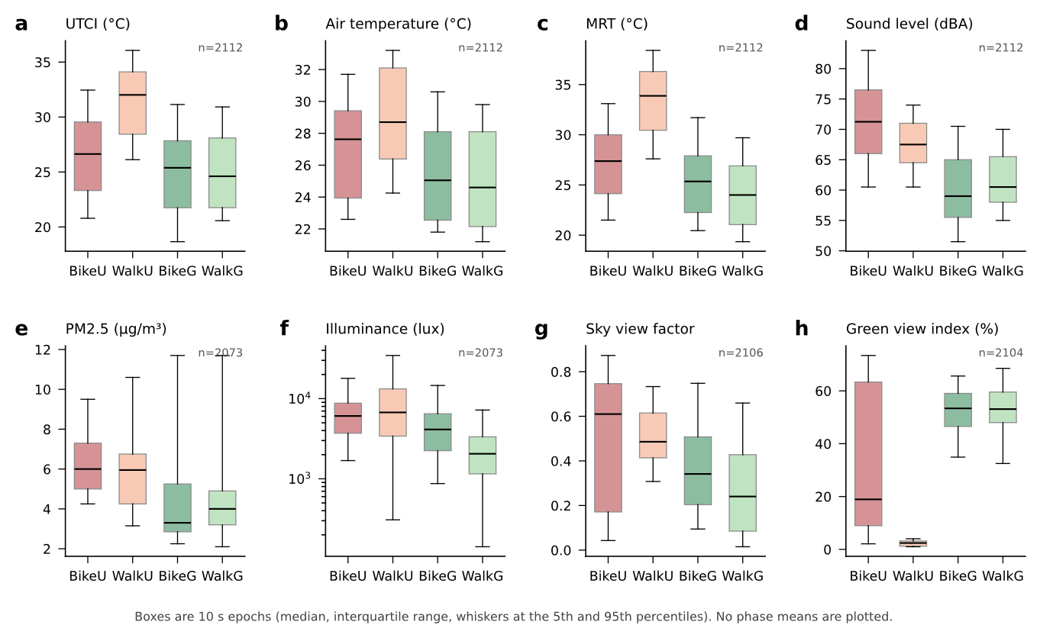
Figure 3. Microclimate and co-exposures by phase on 10 s epochs: UTCI, air temperature, mean radiant temperature, sound, PM2.5, illuminance, sky view and green view.
Participant-weighted phase profiles on the merged 10-second dataset: UTCI/PET, sound, radiation, PM and wind across BikeU, WalkU, BikeG, WalkG (Tram descriptive only). These are the measured exposures for the response contrasts in §3.2–§3.6. Precedent for a walking-transect mixed model of PET: Fahy et al. (2025) — local climate zone and solar energy, not land-surface temperature, explained daytime PET in Geneva; open lawns were hotter than shade under trees or compact streets.

3.2 H1 — Green versus impervious comfort
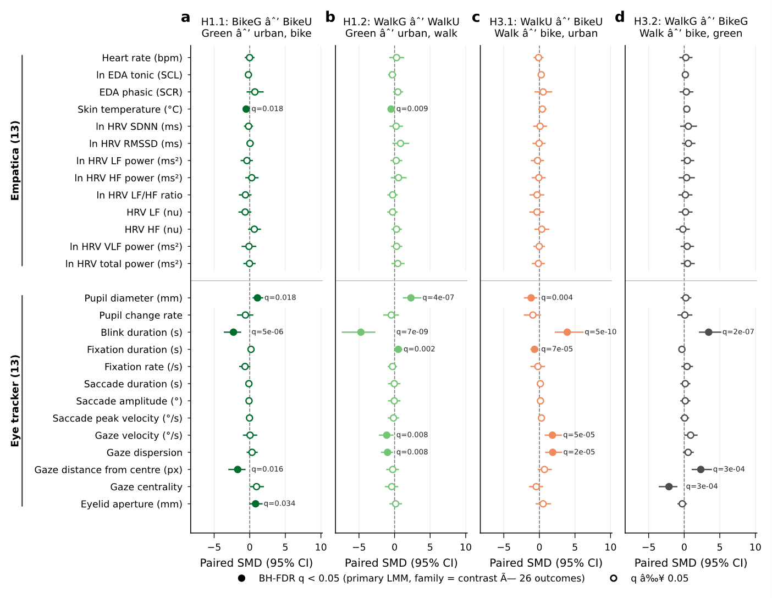
Figure 4. Phase-mean contrasts for green versus impervious phases (H1) and walking versus cycling (H3).
Phase-mean models (§2.3.1); estimates from H1_H3_Contrasts.csv (Hypothesis H1). Green phases were associated with lower skin temperature and with larger pupil diameter (pupil is illumination-sensitive).
Table 3.2. H1 FDR-significant phase-mean contrasts (primary physiological panel; H1_H3_Contrasts.csv, BH within each contrast over 26 outcomes).
Tests (primary physio) | FDR q < 0.05 | Representative FDR hits (green − urban direction)
52 rows (2 contrasts × 26 outcomes; two BH families of n = 26) | 11 | Lower skin temperature (both modes); larger pupil diameter (both); shorter blink duration (both); longer fixation duration (WalkG−WalkU); lower gaze velocity and dispersion (WalkG−WalkU); gaze-centre shift (distance from center, BikeG−BikeU); larger eyelid aperture (BikeG−BikeU). Square-root tonic EDA contrasts did not survive FDR in primary physio families. Pooled 52-test sensitivity: still 11 H1 hits (not the primary rule; §2.3).

*Sensitivity:* 33 q < 0.05 across all H1 rows in the export (primary + WPZ physio + questionnaire families)—report in supplement, not pooled with the primary physio count above.
Outcome | Contrast | β | q~FDR~
empatica_skin_temperature | BikeG − BikeU | −1.12 | 0.018
empatica_skin_temperature | WalkG − WalkU | −1.16 | 0.009
eyetracker_pupil_diameter_avg | BikeG − BikeU | 0.39 | 0.018
eyetracker_pupil_diameter_avg | WalkG − WalkU | 0.95 | <0.001
eyetracker_blink_duration_s | BikeG − BikeU | −0.009 | <0.001
eyetracker_blink_duration_s | WalkG − WalkU | −0.013 | <0.001

3.3 H2 — Physiological and perceived concordance
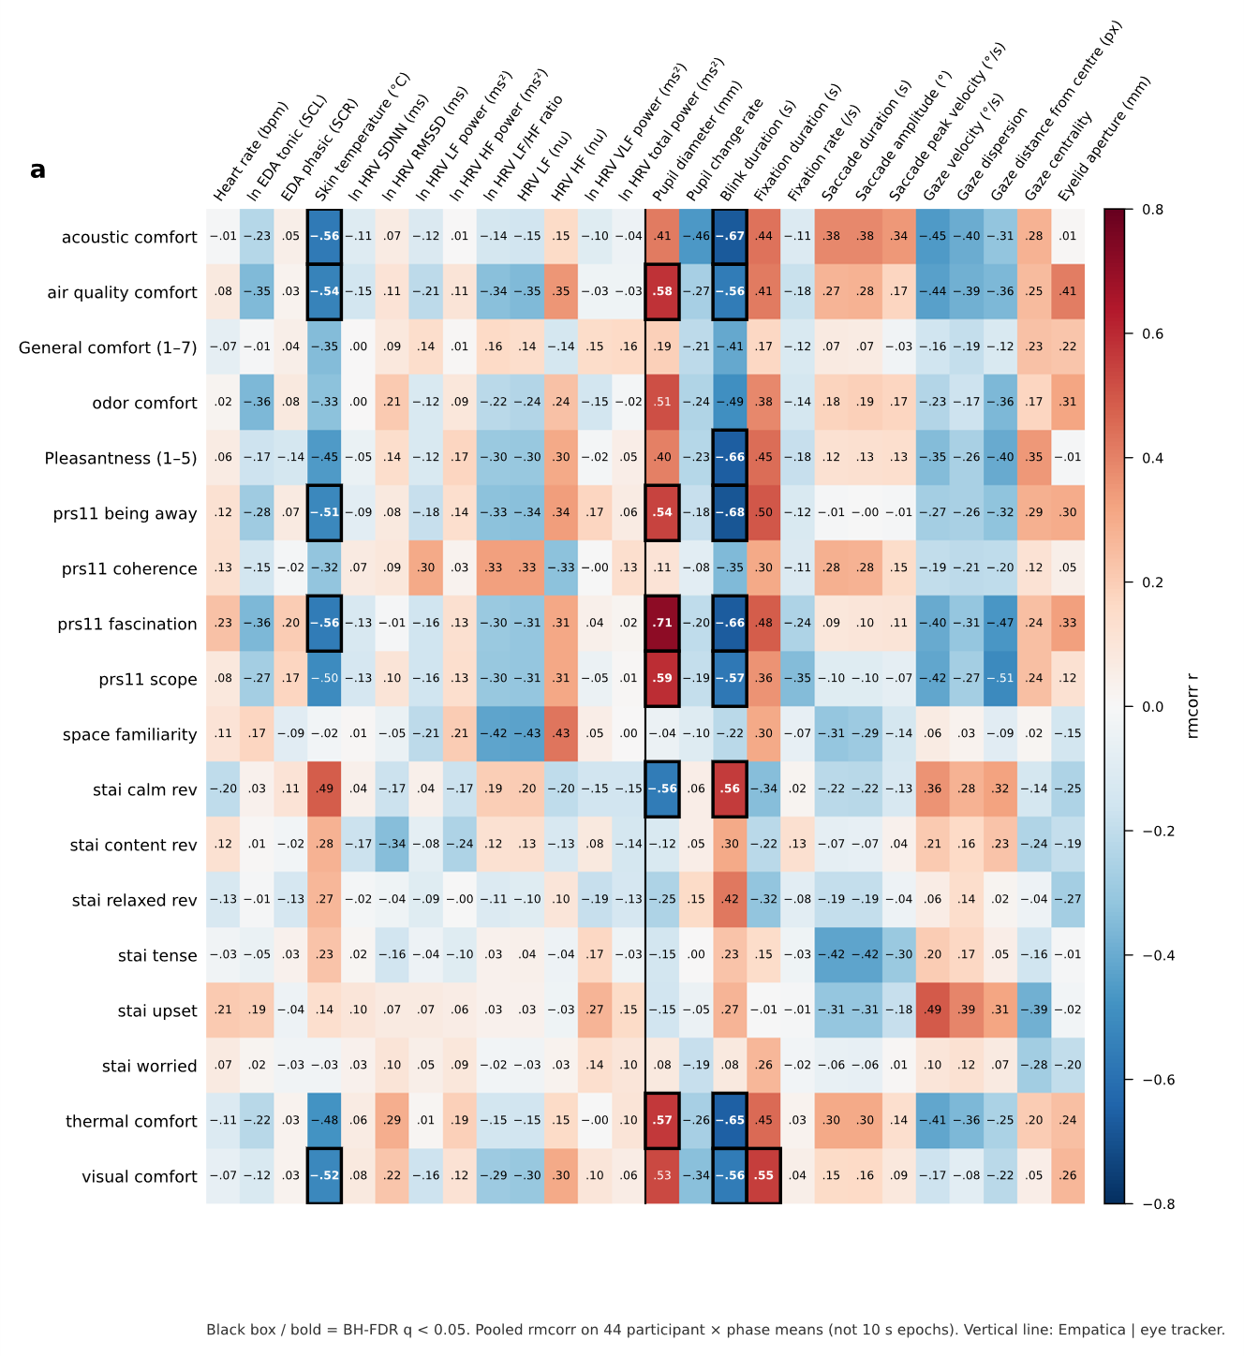
Figure 5. Repeated-measures correlations between end-of-phase questionnaire scores and physiological outcomes (H2).
Unadjusted correlations with votes (§2.3 item 2); export H2_Concordance.csv (468 questionnaire–physiology pairs; one BH family). Twenty-one pairs reached q < 0.05. They couple pleasantness, environmental comfort, calmness and PRS subscales with blink duration, pupil diameter, skin temperature and fixation duration. Heart rate, heart-rate variability and tonic EDA did not.
Tests | FDR q < 0.05
110 fitted (468 prespecified) | 5

Questionnaire | Physiological outcome | r~rmcorr~ | q~FDR~
Pleasantness (1–5) | Blink duration | −0.66 | 0.002
PRS-11 total (1–5) | Skin temperature | −0.63 | 0.002
PRS-11 total (1–5) | Pupil diameter | 0.67 | 0.002
PRS-11 total (1–5) | Blink duration | −0.77 | <0.001
PRS-11 total (1–5) | Fixation duration | 0.56 | 0.029

3.4 H3 — Cycling versus walking
Phase-mean contrasts (§2.3 item 3); H1_H3_Contrasts.csv (Hypothesis H3, normalization Primary). Walking versus cycling showed 8 FDR-significant primary physiological contrasts, all ocular. Tonic EDA, fixation rate, and skin temperature did not survive FDR in this family.
Tests (primary physio) | FDR q < 0.05
52 rows (2 contrasts × 26 outcomes; two BH families of n = 26) | 8

Outcome | Contrast | β | q~FDR~
eyetracker_gaze_velocity | WalkU − BikeU | 609 | <0.001
eyetracker_gaze_dispersion | WalkU − BikeU | 0.019 | <0.001
eyetracker_blink_duration_s | WalkU − BikeU | 0.015 | <0.001
eyetracker_blink_duration_s | WalkG − BikeG | 0.011 | <0.001
eyetracker_fixation_duration_s | WalkU − BikeU | −0.034 | <0.001
eyetracker_distance_from_center | WalkG − BikeG | 52.8 | <0.001
eyetracker_gaze_centrality | WalkG − BikeG | −0.093 | <0.001
eyetracker_pupil_diameter_avg | WalkU − BikeU | −0.46 | 0.004

3.5 H4 — Noise and thermal discomfort
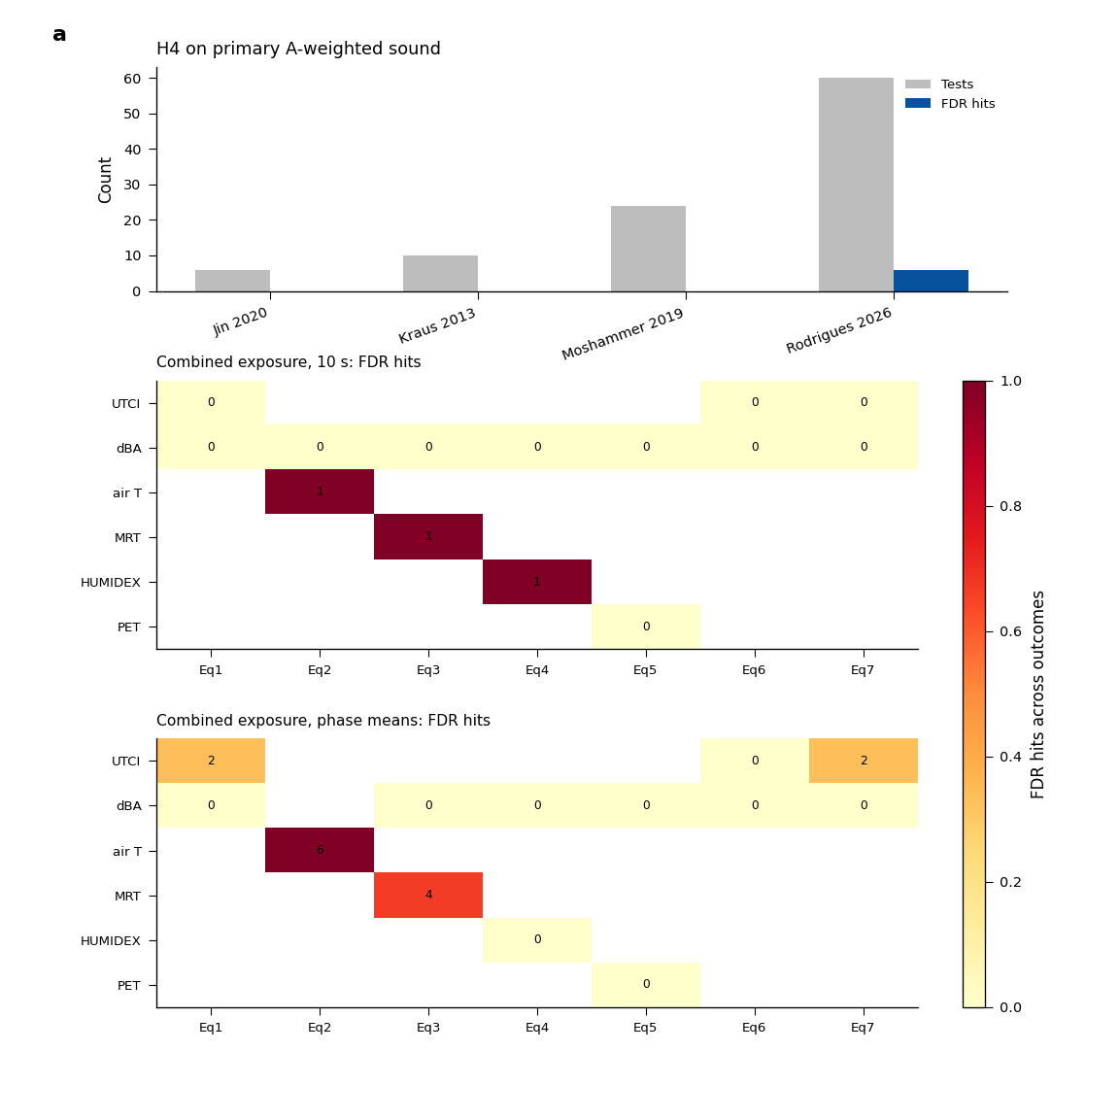
Figure 6. Literature-adapted heat and noise tests on calibrated A-weighted sound (H4).
Primary H4 (locked): H4_sound_literature_test.R → output/statistical_analysis/results/H4_sound_literature_test/ only—not archived H4_phaseavg / H4_timeseries Eq1–7 exports.
On primary ucm_SND_dBA, no Jin dBA × UTCI interaction survived FDR (0/2 perception items). Moshammer Leq slopes and Song walk sensitivity had 0 FDR hits. Rodrigues noise block: 1 FDR-adjusted hit (NOISE_max on MIN_Values under their retention rule). Kraus piecewise slopes: 0 FDR hits on five HRV outcomes. Supplementary sound-class substitutions in the same pipeline are exploratory and not interpreted as calibrated loudness.
Full counts: output/statistical_analysis/results/H4_sound_literature_test/SUMMARY_sound_tests_p_and_FDR.csv (filter sound_variable == ucm_SND_dBA (primary) for manuscript claims).

3.6 Analysis — Combined exposure
Additive Eq1–7 LMMs at 10 s and at phase means (§2.3 item 7). Current exports: 151 / 2158 coefficient rows with q < 0.05 at 10 s (Analysis_combined_timeseries_hypothesis.csv); 45 / 1820 at phase means (Analysis_combined_phaseavg_Heat_Noise_Exposures.csv). Phase Eq3 was not used (maximum VIF 22.48). The 10 s Eq3 was kept.

4 Discussion

4.1 H1 — Green versus impervious comfort
Within each travel mode, green-corridor phases were associated with lower wrist skin temperature and larger pupil diameter, together with shorter blink duration. On foot, the green phase also showed longer fixations and lower gaze velocity and dispersion; while cycling, gaze position shifted toward the visual centre and eyelid aperture increased. Eleven of 52 primary physiological contrasts remained after Benjamini–Hochberg correction within each contrast family. Tonic electrodermal activity did not. The skin-temperature contrast is consistent with a lower radiant and convective load under higher sky and vegetation cover, not with a restoration effect (Boucsein et al., 2012). Pupil diameter co-varies with illuminance as well as with arousal (Mahanama et al., 2021), and the two route types differ in both. Hypothesis 1 is therefore supported for peripheral temperature and selected gaze metrics, and is not supported as a general reduction in autonomic strain.

4.2 H2 — Physiological and perceived concordance
Twenty-one of 468 repeated-measures correlations remained after correction. The surviving pairs couple end-of-phase pleasantness, environmental comfort, calmness and perceived restorativeness with blink duration, pupil diameter, wrist skin temperature and fixation duration. Heart rate, heart-rate variability and tonic electrodermal activity did not. The questionnaires summarise the completed phase, so a single vote is not expected to track every autonomic channel.

4.3 H3 — Cycling versus walking
All eight primary physiological contrasts that survived correction were ocular: gaze velocity and dispersion, blink duration, fixation duration, distance from centre, gaze centrality, and pupil diameter. Wrist skin temperature, tonic electrodermal activity, and fixation rate did not differ between modes after correction. The two modes differ in travel speed, metabolic demand, and the visual demand of monitoring the carriageway (Rupi & Krizek, 2019). The gaze differences are therefore read as mode-specific attentional load, not as a ranking of thermal comfort. Hypothesis 3, that cycling would be more thermally and physiologically compromised than walking, is not established.

4.4 H4 — Noise and thermal discomfort
On calibrated A-weighted level, the Jin heat-by-sound interaction was not significant after correction for either comfort item (0/2). The Moshammer equivalent-level slopes, the Song park-versus-street sensitivity, and the Kraus piecewise slopes likewise yielded no corrected associations on that loudness measure. The Rodrigues noise block retained one noise-term association under that study’s retention rule; that term is not a heat-by-noise interaction. Song’s source comparison contains no sound-level term, and the Jin ANOVA omits a participant effect, so its uncorrected *p*-values are anti-conservative for repeated phases. Heat and sound were co-occurring route exposures rather than assigned treatments, which limits the power to detect an interaction of the magnitude reported in outdoor-square and laboratory studies. Hypothesis 4 is not supported. The result is an absence of evidence in this summer field design, not a demonstration that acoustic load is irrelevant to outdoor thermal discomfort.

4.5 Analysis — Combined exposure
The additive Eq1–7 models describe co-occurring microclimatic, acoustic, and morphological exposures. They are not a hypothesis test. At the 10 s grain, 151 of 2,158 coefficient rows had q < 0.05; at phase means, 45 of 1,820 did. The phase-mean specification that included the full thermal block (Eq3) was excluded because the maximum variance inflation factor was 22.48, so collinear radiant, air, and humidity terms are not interpreted as separate effects at that grain. These family counts are not read term by term in the main text.

4.6 Limitations
The sample is 11 adults in one city over one summer (3 July to 27 August 2025). Environment type and travel mode are confounded with location, sequence, illuminance, metabolic rate, and co-exposures; randomization of route order was planned and is not verified here as a realised counterbalanced sequence. Wrist temperature and electrodermal activity are sensitive to contact and motion, and apparent wind mixes ambient flow with movement-induced airflow at the microphone. No causal attribution of comfort to green infrastructure is made.

5 Conclusion
Phase-mean models of a Brussels summer active-mobility campaign show environment-specific differences in wrist skin temperature and visual attention, and mode-specific differences that are confined to ocular kinematics. Broad concordance between end-of-phase comfort ratings and autonomic physiology was not confirmed (21 of 468 fitted pairs), and no heat-by-noise amplification survived correction in the literature-adapted tests on calibrated A-weighted sound. The findings support context-dependent psychophysiological responses to outdoor microclimate and route type, not a general ranking of green versus impervious corridors or of walking versus cycling. Larger multi-season samples, with exposures that are less collinear than the observed summer routes, are required before combined-exposure interactions can be treated as design evidence.

6 References
Boucsein, W., et al. (2012). Publication recommendations for electrodermal measurements. Psychophysiology, 49(8), 1017-1034. https://doi.org/10.1111/j.1469-8986.2012.01384.x
Chinazzo, G., Wienold, J., & Andersen, M. (2019). Daylight affects human thermal perception. Scientific Reports, 9, 13690. https://doi.org/10.1038/s41598-019-48963-y
Evans, K. M., Jacobs, R. A., Tarduno, J. A., & Pelz, J. B. (2012). Collecting and analyzing eye-tracking data in outdoor environments. Journal of Eye Movement Research, 5(2), Article 6.
Fahy, J. C., Bachofen, C., Camponovo, R., Gallinelli, P., & Schlaepfer, M. A. (2025). Beyond land surface temperature: Identifying areas of daytime thermal discomfort in cities by combining remote sensing and field measurements. Urban Climate, 61, 102460. https://doi.org/10.1016/j.uclim.2025.102460
Mahanama, B., et al. (2021). Eye movement and pupil measures: A review. Frontiers in Computer Science, 3, 733531. https://doi.org/10.3389/fcomp.2021.733531
Mansi, S. A., Pigliautile, I., Arnesano, M., & Pisello, A. L. (2022). A novel methodology for human thermal comfort decoding via physiological signals measurement and analysis. Building and Environment, 222, 109385. https://doi.org/10.1016/j.buildenv.2022.109385
Nikolopoulou, M., Baker, N., & Steemers, K. (2001). Thermal comfort in outdoor urban spaces: Understanding the human parameter. Solar Energy, 70(3), 227-235. https://doi.org/10.1016/S0038-092X(00)00093-1
Quigley, K. S., et al. (2024). Publication guidelines for human heart rate and heart rate variability studies in psychophysiology - Part 1. Psychophysiology, 61, e14604. https://doi.org/10.1111/psyp.14604
Rupi, F., & Krizek, K. J. (2019). Visual eye gaze while cycling: Analyzing eye tracking at signalized intersections in urban conditions. Sustainability, 11(21), 6089. https://doi.org/10.3390/su11216089
Stuyck, H., Dalla Costa, L., Cleeremans, A., & Van den Bussche, E. (2022). Validity of the Empatica E4 wristband to estimate resting-state heart rate variability in a lab-based context. International Journal of Psychophysiology, 182, 105-118. https://doi.org/10.1016/j.ijpsycho.2022.10.003
Cooper, J., & Evans, T. (2015). Microphone wind speed limits during wind farm noise measurements. Proceedings of the Australian Acoustical Society Conference, Hunter Valley. (Wind-on-microphone limits; 5 m/s exclusion not sufficient alone.)
Zuo, J., Xia, H., Liu, S., & Qiao, Y. (2016). Mapping urban environmental noise using smartphones. Sensors, 16(10), 1692. https://doi.org/10.3390/s16101692 (Mobile noise mapping; windscreens; avoid measurement above ~5 m/s.)
ISO 1996-2:2017. Acoustics — Description, measurement and assessment of environmental noise — Part 2: Determination of sound pressure levels. (Outdoor measurement conditions; local preview in Experiment papers.)
Federal Highway Administration. Noise barrier design / field measurement guidance. https://www.fhwa.dot.gov/environment/noise/ (Windscreens; do not measure when wind at microphone exceeds ~5 m/s.)
Gong, F.-Y., et al. (2018). Mapping sky, tree, and building view factors of street canyons. Building and Environment, 134, 155–167. https://doi.org/10.1016/j.buildenv.2018.02.042
Gong, Z., Ma, Q., Kan, C., & Qi, Q. (2019). Classifying street spaces with street view images for a spatial indicator of urban functions. Sustainability, 11(22), 6424. https://doi.org/10.3390/su11226424

Supplementary figures
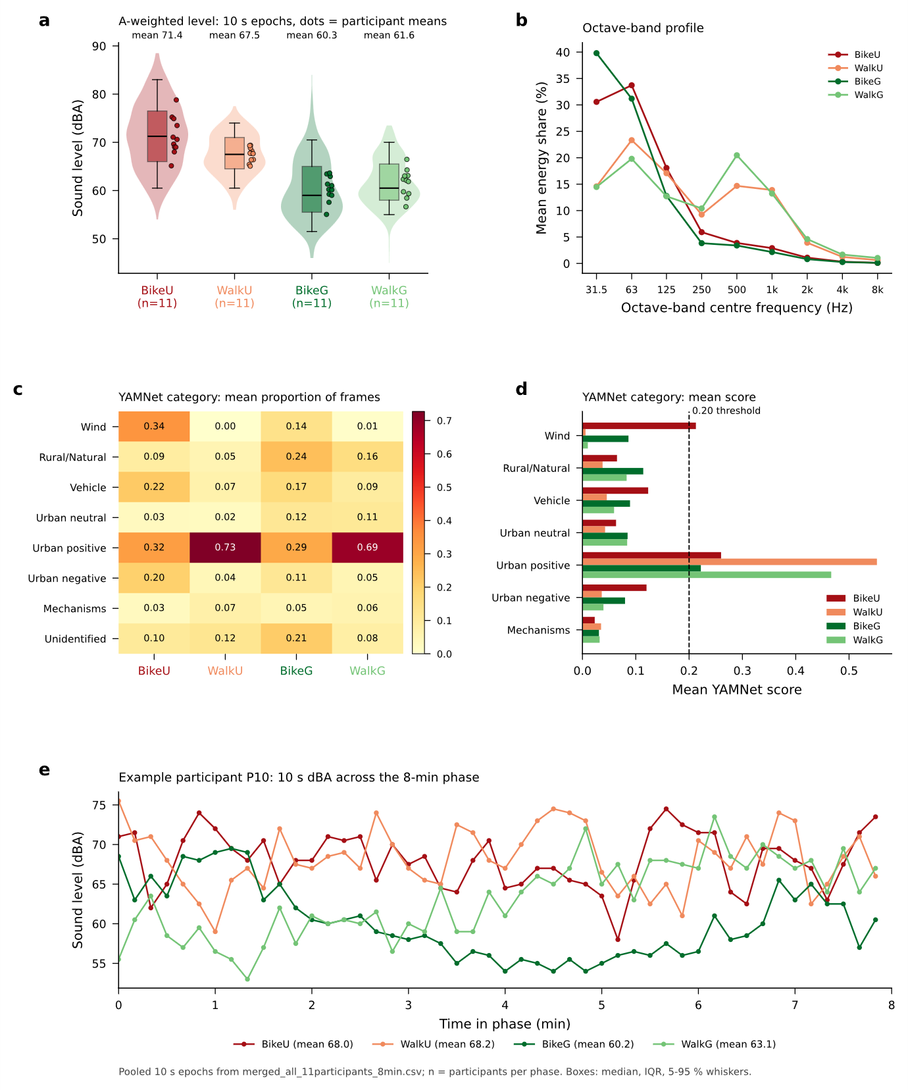
Figure 7. Sound composition along the routes. Calibrated loudness claims use A-weighted level, not these class shares.
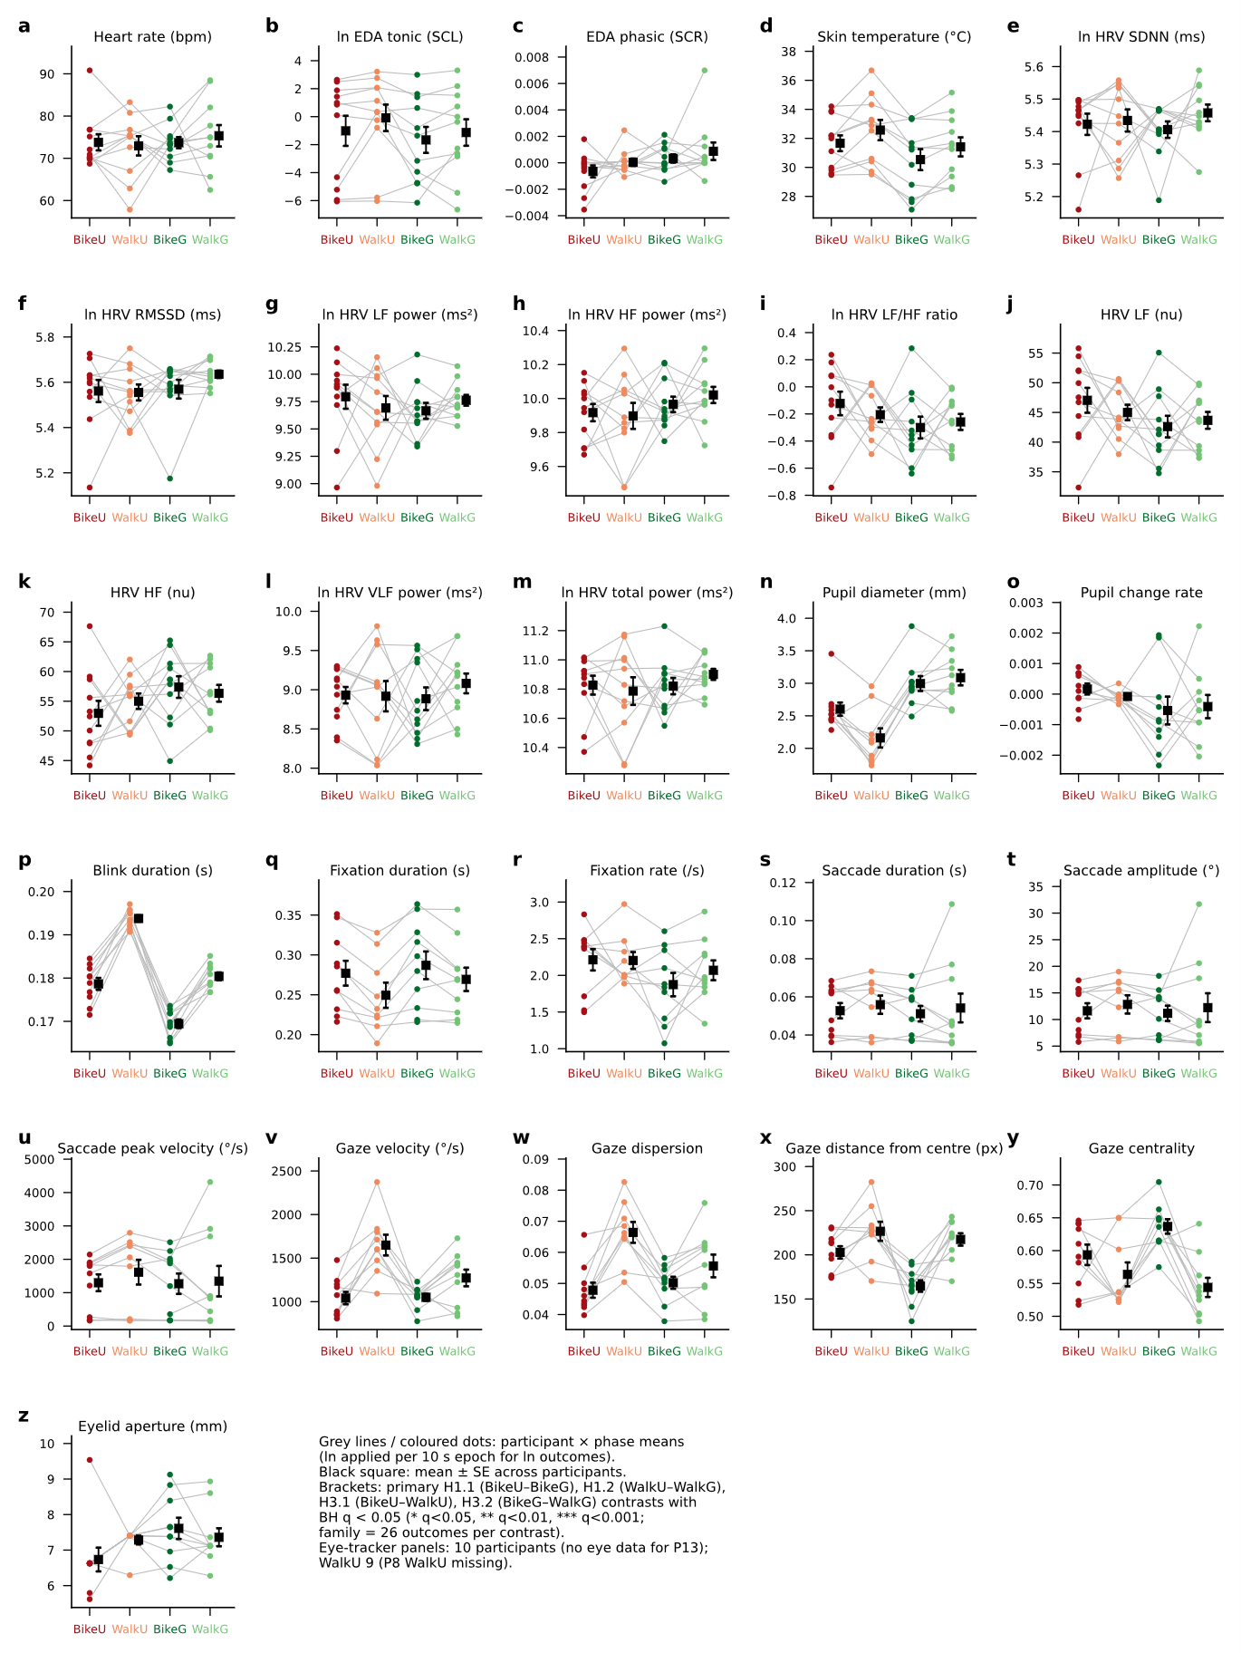
Figure 9. Physiological and ocular outcomes by phase.
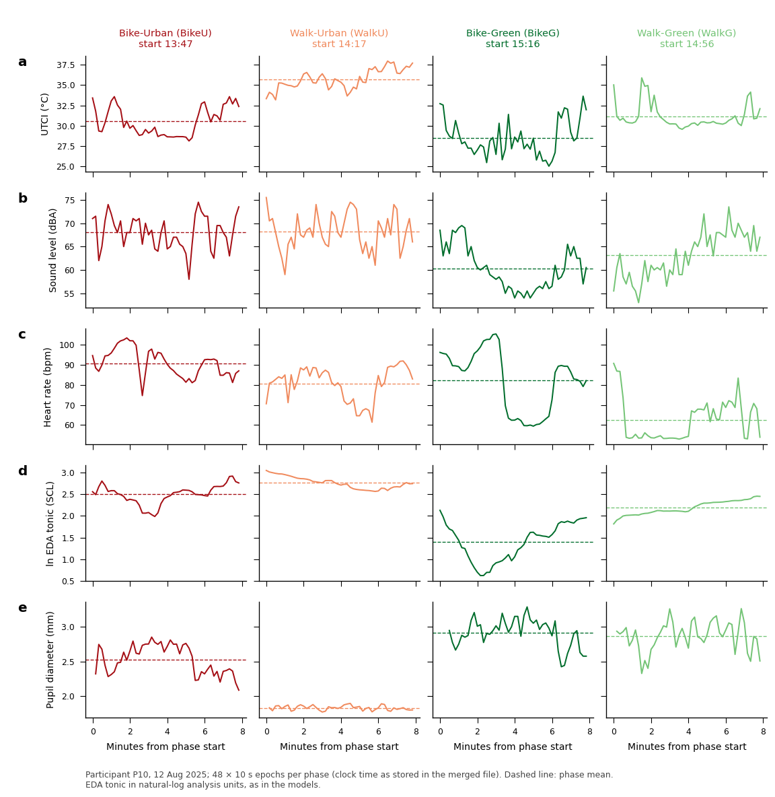
Figure 10. Example synchronized traces.

